Piperacillin TDM Summary

# First Name Last Name (URN: 999999)

## Patient and Previous Dosing Details

|  |  |
| --- | --- |
| **Characteristics** | **Value** |
| Age (years) | 85.6 |
| Weight (kg) | 61.1 |
| Gender | Male |
| Serum Creatinine (µmol/L) | 60.2 |
| Creatinine Clearance (mL/min) | 68 |

|  |  |
| --- | --- |
| **Prescribed Dosing Information** | **Value** |
| Dose Amount (mg) | 4000 |
| Dose Frequency (hours) | 6-hourly |
| Infusion Duration (hours) | 3 |
| Number of Previous Doses | 2 |

|  |  |
| --- | --- |
| **Concentration (mg/L)** | **Time after Infusion Started (hours)** |
| 1: 70 | 1 |
| 2: 20 | 5 |
| 3: NA | NA |
| 4: NA | NA |

## Individual Pharmacokinetic Parameters

|  |  |
| --- | --- |
| **Estimated Parameters** | **Value (95% CI)** |
| Clearance (L/hour) | 11.8 (10.4 - 12.8) |
| Volume of Distribution (L) | 14.4 (11 - 16.8) |
| Time above MIC for Sampled Dose (%) | 100 (100 - 100) |

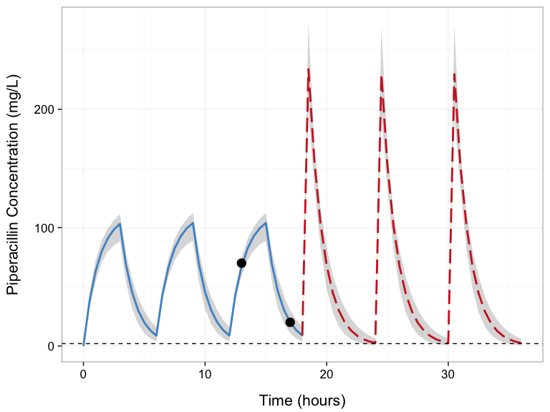

## Recommended Dosing Regimen

|  |  |
| --- | --- |
| **New Dosing Information** | **Value** |
| Dose Amount (mg) | 4000 |
| Dose Frequency (hours) | 6-hourly |
| Infusion Duration (hours) | 0.5 |

|  |  |
| --- | --- |
| **Predictions** | **Value (95% CI)** |
| Time above MIC for Next 3 Doses (%) | 100 (76.9 - 100) |

*[Type your overall dosing recommendations here]*

**Prepared by:** Your Initials (Pharmacist) **Date:** 14-03-2016